SILAHKAN LENGKAPI DATA BERIKUT
NO | NAMA LENGKAP PENULIS | AFILIASI | NO HP/WA | Email | NO. ORCID | Id Google Scholar | TTD
1 | Agus Limanto* | ⁶Department of Biochemistry and Biomolecular, Faculty of Medicine and Health Sciences, Krida Wacana Christian University, West Jakarta, 11510, Indonesia | 08176777781 | agus.limanto@ukrida.ac.id | https://orcid.org/0000-0002-6037-1271
2 | Glenn Marchelinno Souissa | ¹School of Medicine, Faculty of Medicine and Health Sciences, Krida Wacana Christian University, West Jakarta, 11510, Indonesia |  | glenn.102022151@civitas.ukrida.ac.id | https://orcid.org/0009-0006-1783-1208 |  | 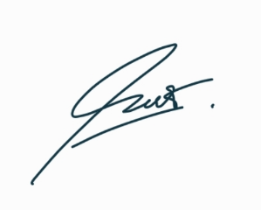
3 | Bryan Christopher Wiraputra | ¹School of Medicine, Faculty of Medicine and Health Sciences, Krida Wacana Christian University, West Jakarta, 11510, Indonesia |  | bryan.102022052@civitas.ukrida.ac.id | https://orcid.org/0009-0003-8860-3833 |  | 
4 | Deby Deby | ²Department of Histopathology and Anatomy, Faculty of Medicine and Health Sciences, Krida Wacana Christian University, West Jakarta, 11510, Indonesia |  | deby.deby@ukrida.ac.id | https://orcid.org/0009-0006-2394-1972
5 | Purnamawati | ²Department of Histopathology and Anatomy, Faculty of Medicine and Health Sciences, Krida Wacana Christian University, West Jakarta, 11510, Indonesia |  | purnamawati@ukrida.ac.id | https://orcid.org/0000-0002-4804-3785
6 | Eden Steven | ³Emmerich Research Center, North Jakarta, 14450, Indonesia |  | eden.steven@gmail.com | https://orcid.org/0000-0003-4591-487X |  | 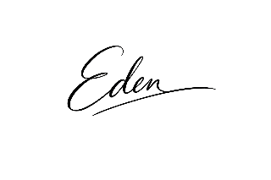
7 | Yudhi Nugraha | ⁴Eijkman Research Center for Molecular Biology, National Research and Innovation Agency (BRIN), Cibinong, Bogor, 16911, Indonesia |  | yudhi.nugraha@brin.go.id | https://orcid.org/0000-0003-1186-4093 |  | 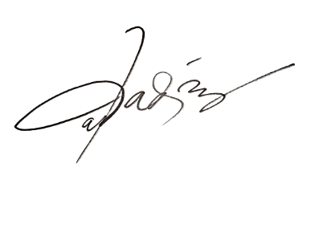
8 | Ahmad Novi Muslimin | ⁵Physics and Advanced Imaging Laboratory, National Research and Innovation Agency (BRIN), Cibinong, Bogor, 16911, Indonesia |  | ahmadnovimuslimin20@gmail.com | https://orcid.org/0000-0002-2174-5461 |  | 

Keterangan : Penulis yang sebagai Correspondence Authors diberi tanda (*) di belakang namanya

